- Enter the names of the numbered elements in the image below
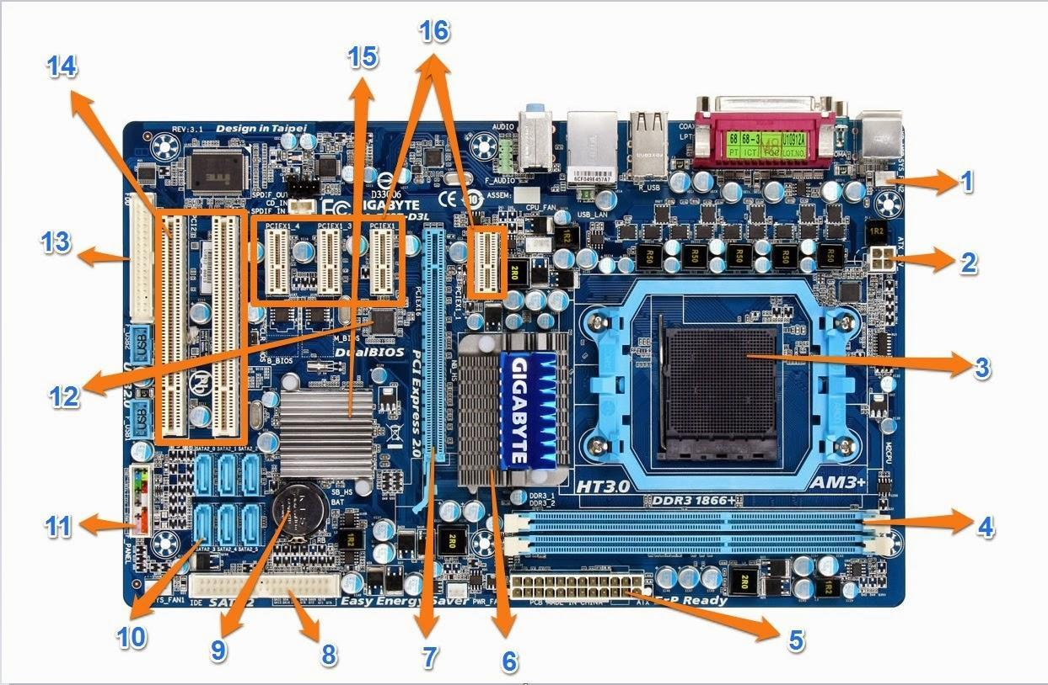
2. Enter the names of the numbered elements in the image below
